In this example we will use a BADI relevant for tcode MIRO (Income Invoice) to automatically populate a text in the header of the generated accounting document.

1. **Finding the right BADI**

Go to tcode MIRO and activate debug mode.

Create a Breakpoint as follow:

Enter class name: *cl_exithandler* and method *get_instance*

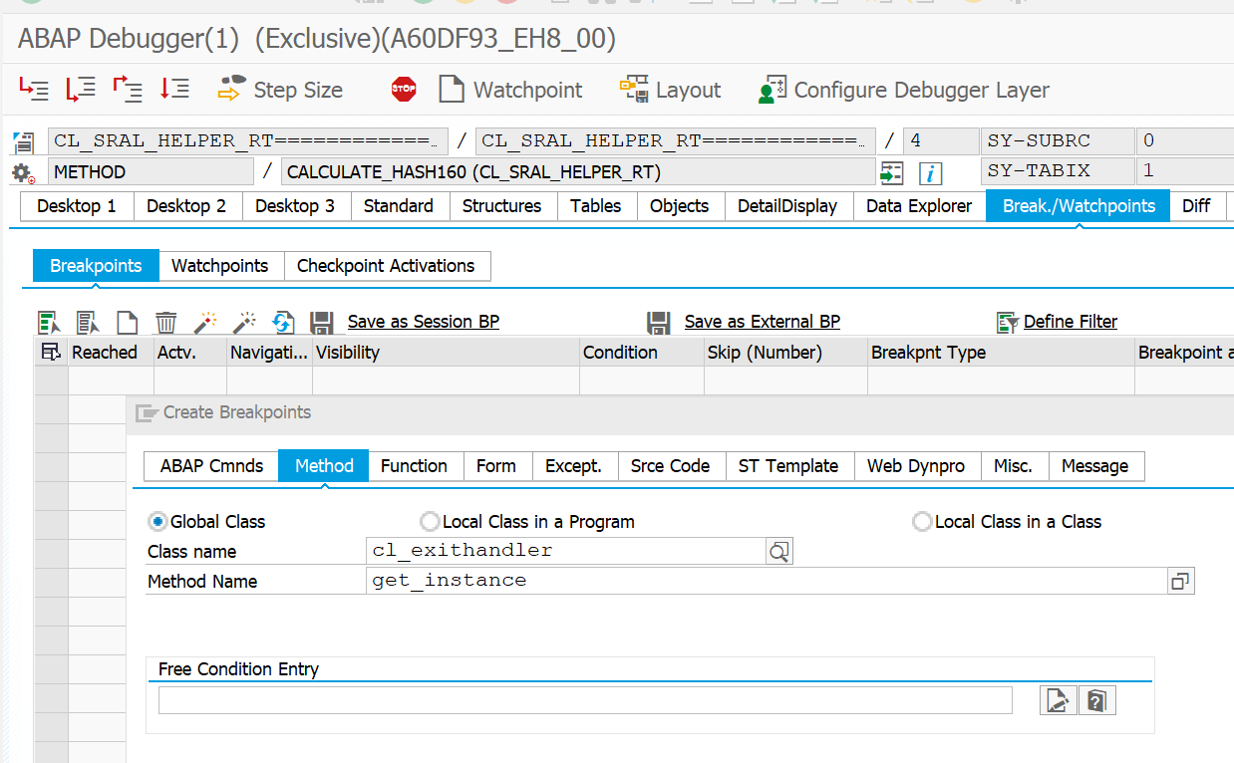

The program execution will stop in every BADI call and the BADI name can be inspected in the parameter EXIT_NAME.

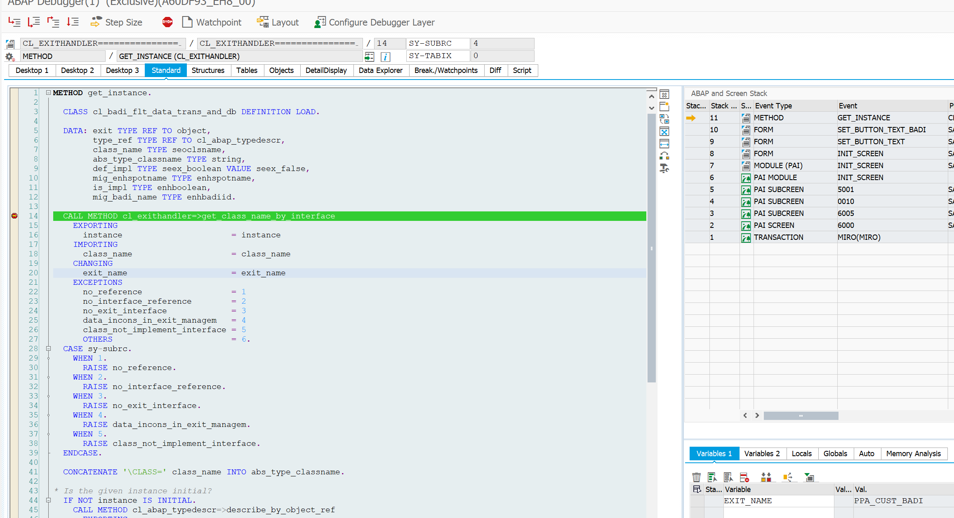

Check all BADIs in tcode SE18 to find out which one fulfill the requirement.

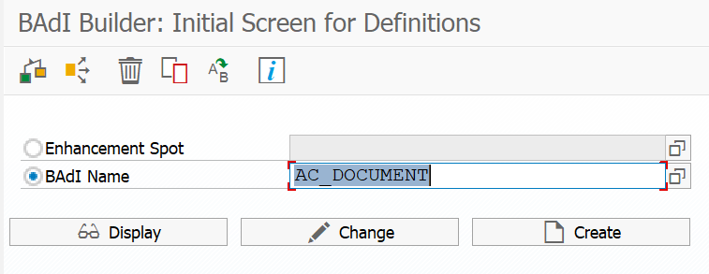

We will use the BADI AC_DOCUMENT after checking the documentation.

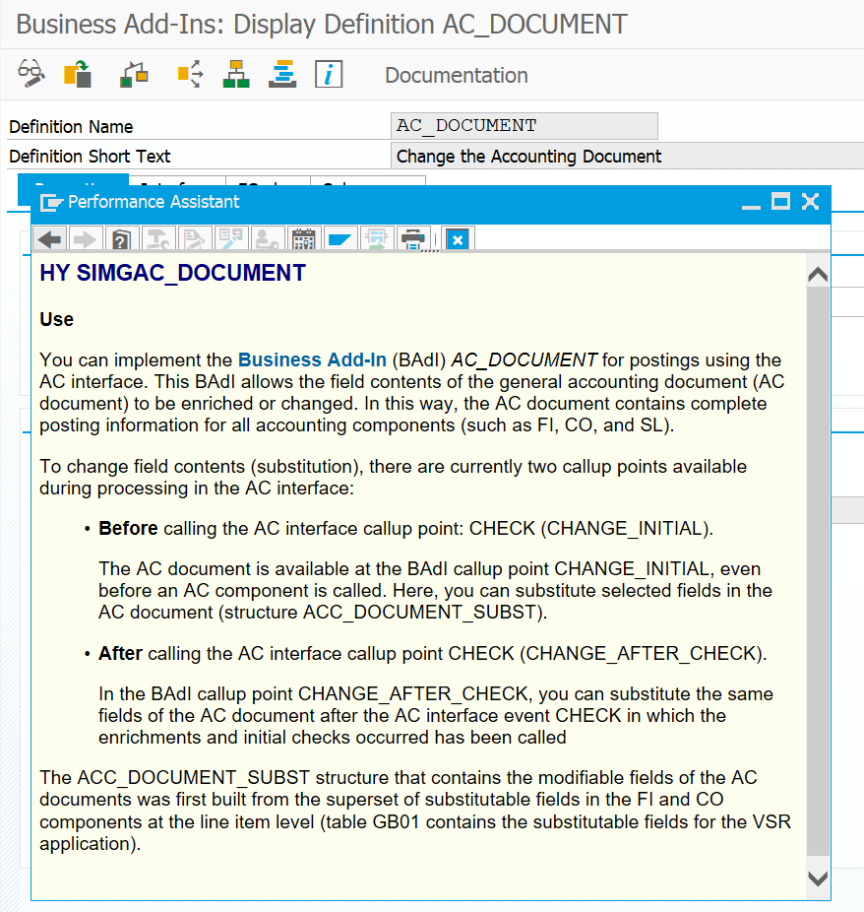

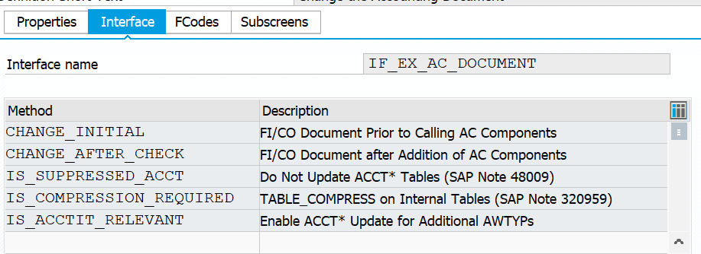

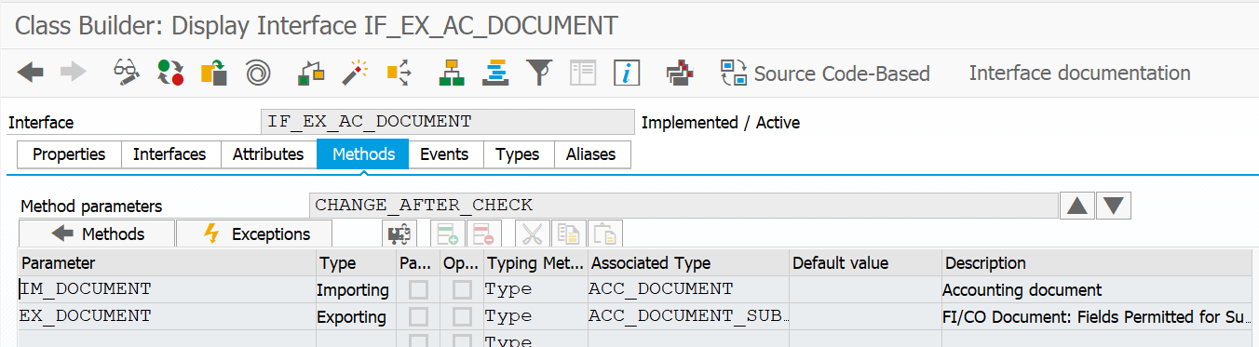

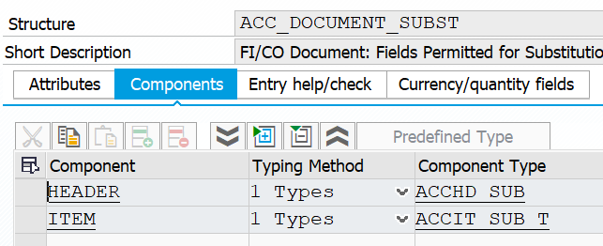

We see that the field Document Header Text is available to be exported:

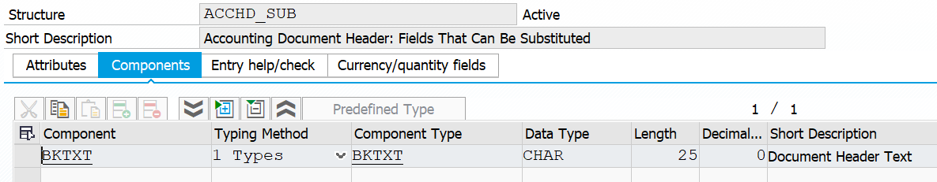

1. **Implement the BADI**

Tcode SE19, click create and choose a name for the implementation:

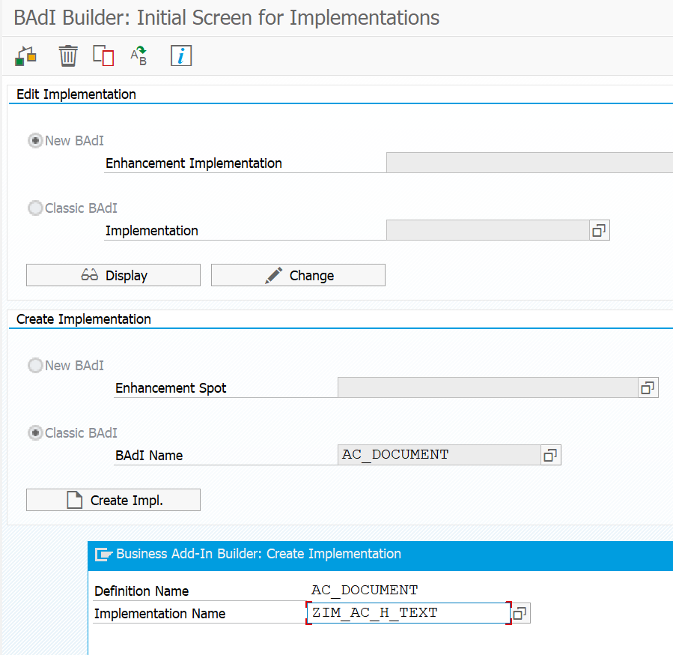

Implement the below code and activate:

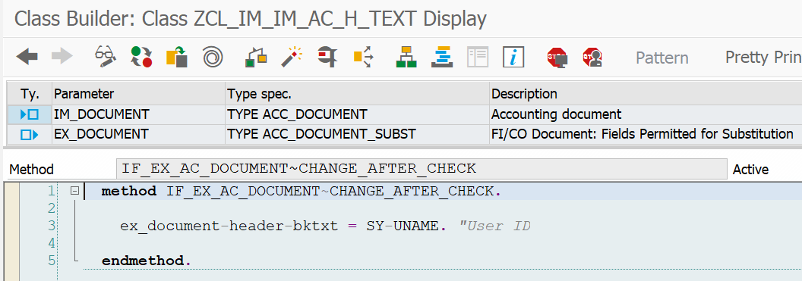

Go back and activate the BADI.

1. Testing

Create a invoice in tcode MIRO



Open the document on tcode MIR4 and open the header of the accounting document. The text should be the user ID.

